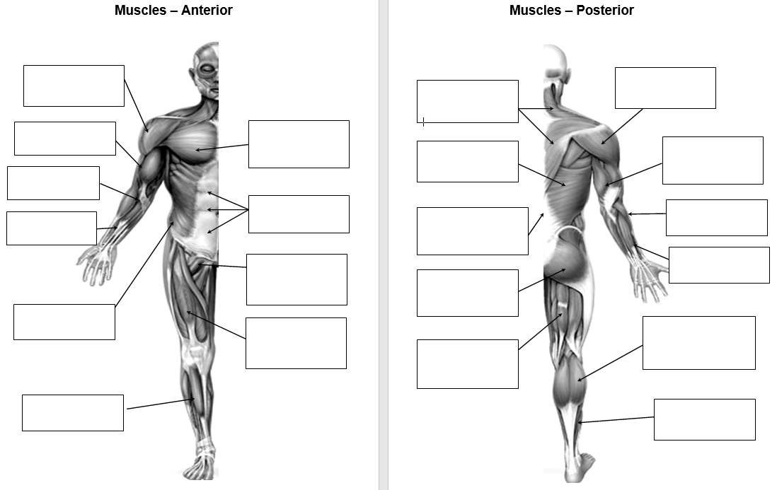

BLANK SKELETON - Task: Practice labelling the skeletal and muscular system

